DDL Commands :
1. Table Creation (CREATE): Write the SQL statements to create a database named
“employee” and the following tables based on the provided schema:
⦿ Departments
⦿ Location
⦿ Employees
create database employee;
use employees;

CREATe TABLE departments(
department_id int PRIMARY KEY,
department_name VARCHAR(30)
);
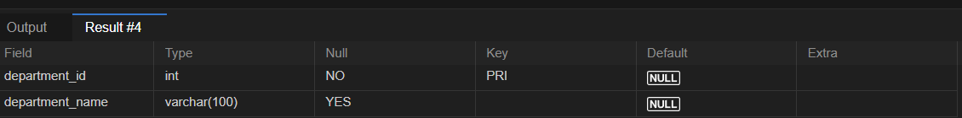
CREATE TABLE location(
location_id int PRIMARY KEY,
location VARCHAR(30)
);
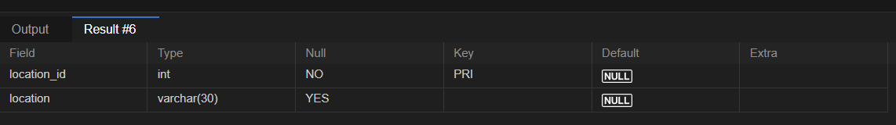
CREATE TABLE employees(
employee_id int PRIMARY KEY,
employee_name VARCHAR(50) NOT NULL,
gender ENUM('m','f'),
age int,
hire_date DATE,
designation VARCHAR(100),
department_id int,
location_id INT,
salaty DECIMAL(10,2),
FOREIGN KEY(department_id) REFERENCES departments(department_id),
FOREIGN KEY(location_id) REFERENCES location(location_id)
);
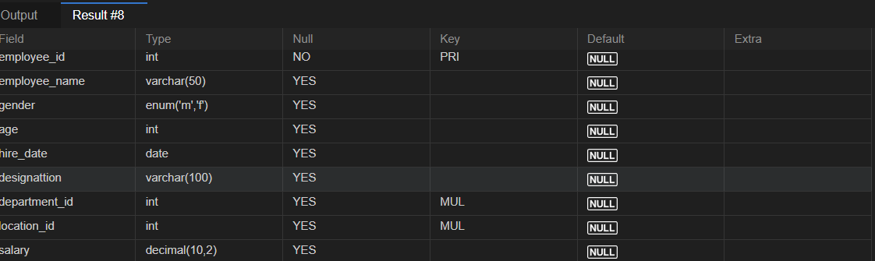
2. Table Alteration (ALTER): Consider the following scenarios and write the SQL
statements to alter the structure of the tables accordingly:
⦿ Add a new column named "email" to the Employees table to store
employee email addresses.
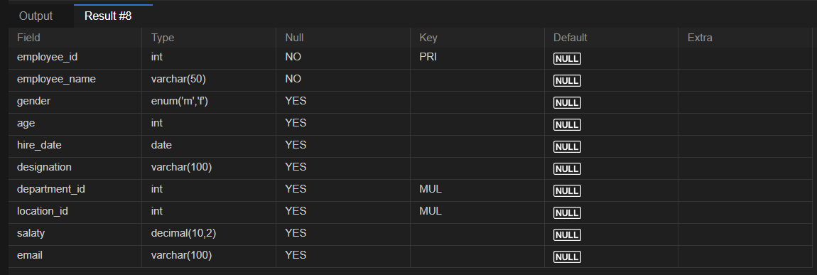
⦿ Modify the data type of the "designation" column in the Employees
table to support a wider range of values.
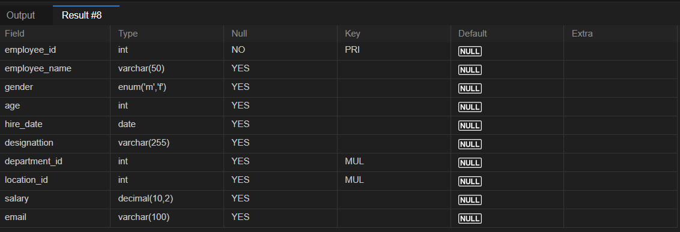
⦿ Drop the “age” column from the Employees table.
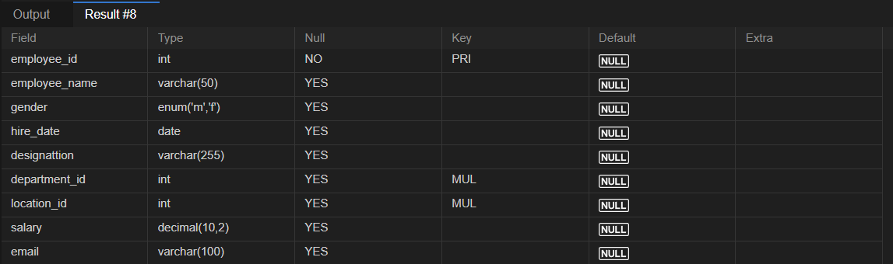
⦿ Rename the “hire_date” column to “date_of_joining”.
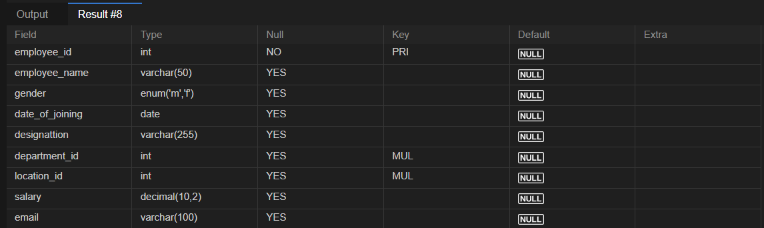
3. Table Renaming (RENAME): Rewrite the SQL statements to rename the
following tables:
⦿ Rename the "Departments" table to "Departments_Info".
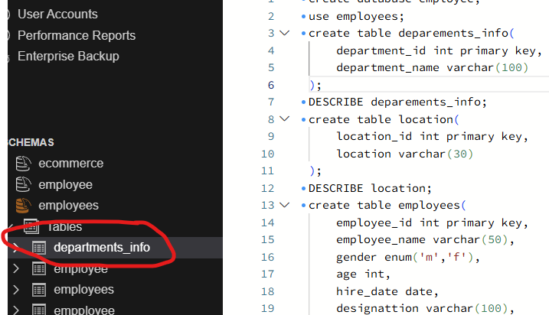
⦿ Rename the "Location" table to "Locations".
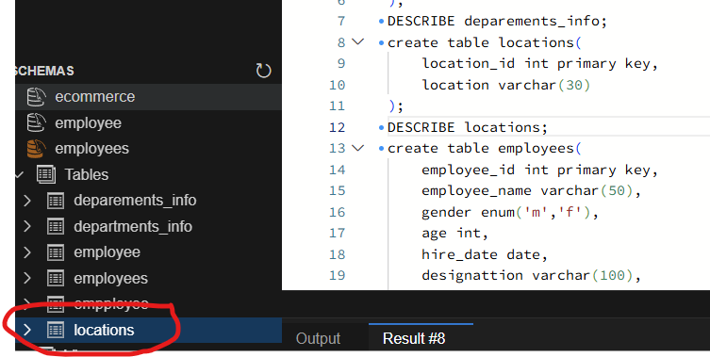
4. Table Truncation (TRUNCATE): Write an SQL statement to truncate the
Employees table.
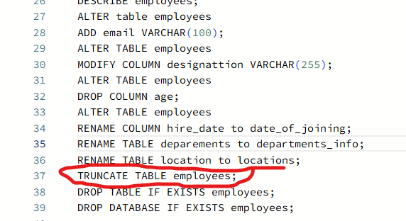
5. Database & Table Dropping (DROP): Write the SQL statements to drop the
Employees table and then the “employee” database.
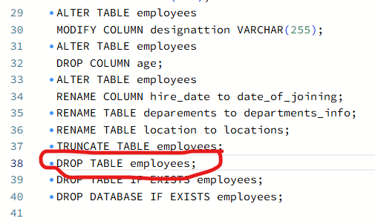
Constraints :
1. Database Recreation:

⦿ Drop the 'employee' database if it exists and recreate it using the
provided schema, ensuring that all tables are created with the
appropriate constraints as instructed.
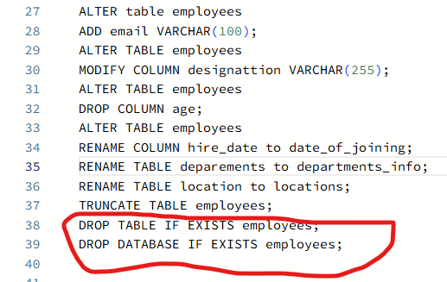
2. Departments Table:

⦿ Ensure that the "department_id" uniquely identifies each department.
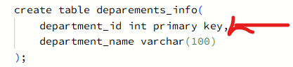
⦿ Set up constraints on the "department_name" to avoid duplicate and null
entries.
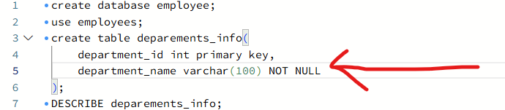
3. Location Table:

⦿ Establish a mechanism to automatically generate unique identifiers for
each location, ensuring that they are incremented sequentially.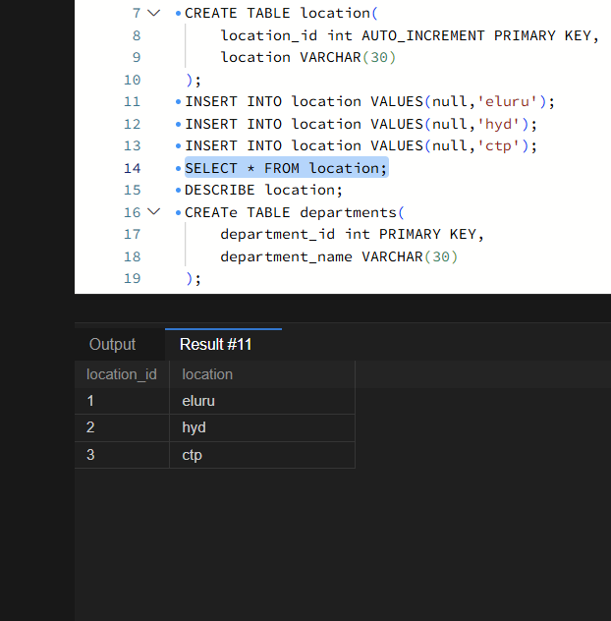
⦿ Implement constraints to prevent the insertion of null and duplicate
Locations.
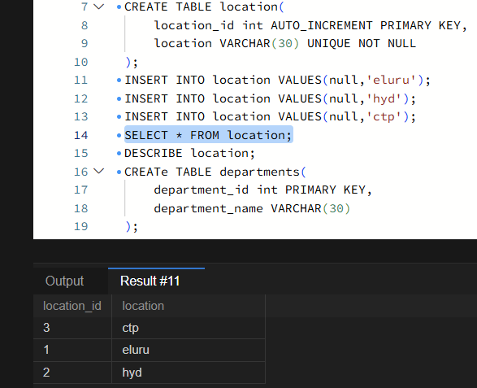
4. Employees Table:
⦿ Create a restriction to ensure that the employee's name is always
provided.
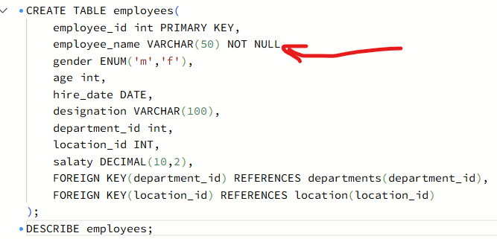
⦿ Limit the acceptable values for the "gender" field to only 'M' or 'F'.
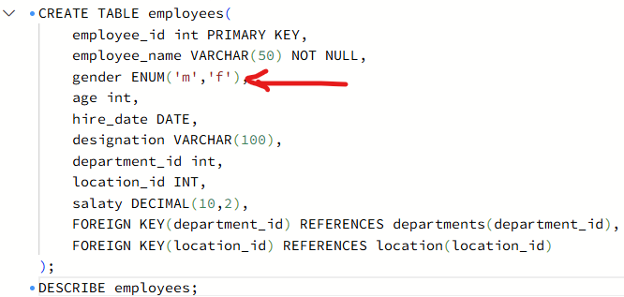
⦿ Enforce a condition to ensure that the employee's age is 18 or above.
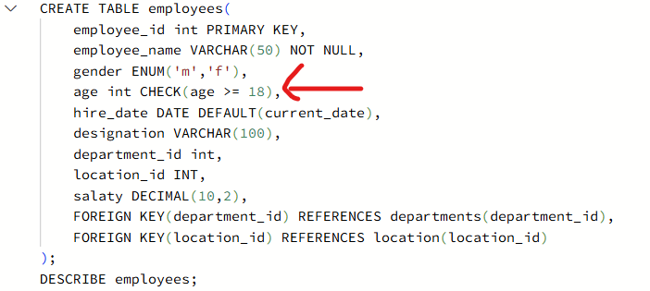
⦿ Automatically assign the current date to the "hire_date" field if not
specified.
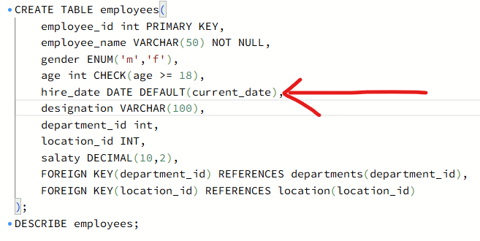
⦿ Establish links between the "department_id" and "location_id" fields in
the "employees" table and their respective tables.
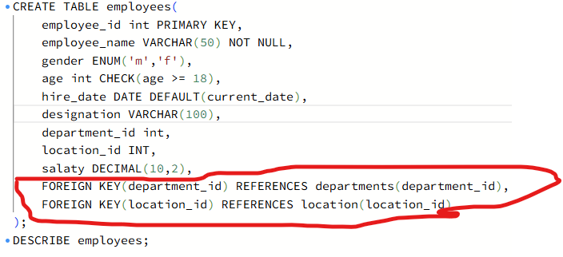
⦿ Guarantee that each employee has a distinct identifier.


